**Message Boxes**

A ***message box*** is a simple device for displaying messages on the screen. When executed, the following line of code pops up a message box:

messageBox ("Hello world!");

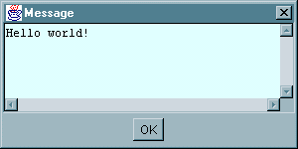

To dismiss the message box click the **OK** button or the **X** in the top right corner of the window. The method messageBox can also accept a double or an int as a parameter.